Medicine Woman Coaching
by Susan Kersey

THE ELEMENT OF EARTH
Introspection • Intuition • Wisdom

In the Medicine Woman mysteries, we engage with the element of air in order to receive the wisdom carried within - and on the wind.

When we enter the silence…
The intuitions, or messages we receive, are whispered to us from the sacred space within ourselves, if only we learn to listen by entering the silence.

Call in sacred space: Work with a crystal bowl, vibrational tool, or air meditation
When we treat our bodies as vessels for healing, we are granted the gift of discernment. We are able to understand, to know, the sacred truths with which we have been trusted – and what to do with them.

Receive sacred truths: Nurture them inside our persons
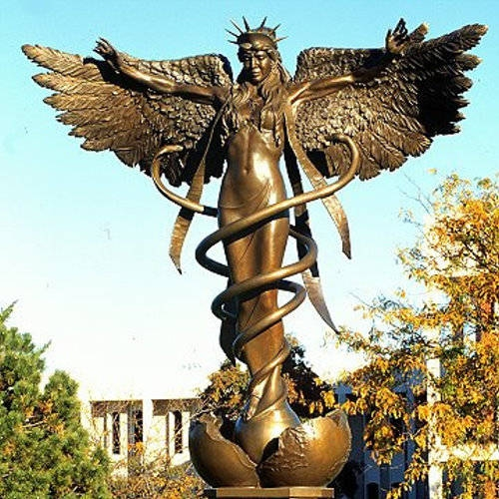
Nurturance is needed to bring sacred truths into form and give them structure. We digest these as we do nourishment and break them into pieces that we might more easily absorb what we have learned. As we take the practical steps required to give wings to our truth, we are able to actively create our personal goals and desires.

The Angel Caduceus reminds us of our sacred charge as Medicine Women to:
~ Explore higher consciousness unencumbered by distractions
~ Bypass masculine and feminine duality and reconcile those within ourselves so we can teach others
~ Choose freedom and liberation from struggle
~ Honor our uniqueness within the tribe of those who express the sacred trust of the Medicine Woman through her works
~ Release illusions of consensus reality as higher truths to emerge

Are you ready to participate with the Medicine Woman through the Element of Air?

