Medicine Woman Coaching
by Susan Kersey
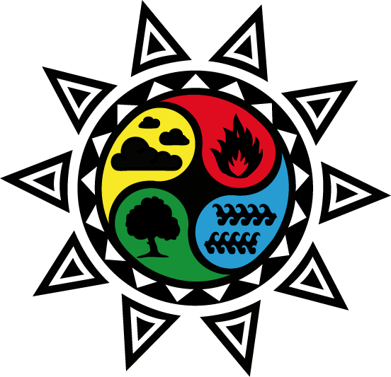

THE ELEMENT OF EARTH
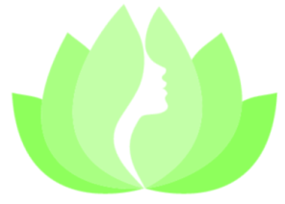
Manifestation • Self Care • Right Relationship

In the Medicine Woman mysteries, we engage with the element of earth in order to receive the gift of manifestation – what we reap, we sow.

When our soles and souls connect…
The body of the earth and our own bodies are each sacred space. We walk on one in balanced right relationship with the other. When our relationship with the world is compromised, so is our ability to create our desires in the real world. That’s why it’s important to connect with the earth as the creative aspect of the feminine, and to build strong foundations for our work.

Call in sacred space: Work with crystals, clay, or healing plants
When we treat our bodies as vessels for healing, earth grants us the gift of right relationship with ourselves, others, and the natural world. We are able to receive the nurturance, healing touch, and plant medicines we need in order to fully embody our purpose on the planet at this time.
Receive sacred truths: Nurture them inside our persons
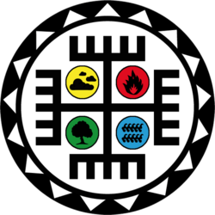

Walking our talk on the earth is needed to optimize our health potential. When we refuse to acknowledge our feelings, we stuff them into our bodies where they become illness. As we take the practical steps required for manifestation, we are able to actively co-create with spirit the world in which we wish to live.

The Medicine Wheel reminds us of our sacred charge as Medicine Women to:
~ Combine stability with action to create our livelihoods and desires
~ Remember our place at the center of the wheel, and our relationship to above, below, and the directions
~ Plan our work, and work our plan, whether for personal or planetary healing or selfcare in all its forms
~ Honor our tribe of choosing and our ancestors of birth through our actions, choices, and respect for all beings
~ Receive the gifts of earth in order to help and to heal
~ Release anything which does not serve from our body and our personal and sacred spaces

Are you ready to participate with the Medicine Woman through the Element of Earth?

