Medicine Woman Coaching
by Susan Kersey
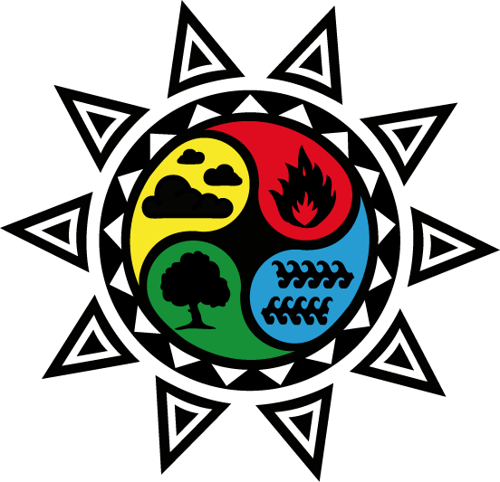

THE ELEMENT OF FIRE
Movement • Passion • Activation

In the Medicine Woman mysteries, we engage with the element of air in order to receive the wisdom carried within - and on the wind.

When we enter the heat…
The expansion of our energy in the world is the impulse of fire we carry within. Our passions are the spark which lights us from within and gives us the impetus we need to realize our desires.

Call in sacred space: Work with dance, drumming, and flames
The knowing, or messages we receive, are rhythmic. Our heartbeats, our dance on the earth, and the rhythms of cicadas, reflect the unfolding dance of the “as above so below” mysteries. We learn to experience spirit by connecting with nature and choosing ecstatic expression through our bodies. We stare into the fire to receive the knowledge revealed within the embers. We infuse candles with our desires and allow the flame to focus our attention and light the way. We use fire – and fire breath – to clear and cleanse anything that blocks our highest and best outcomes.
Connect with the Ancients: Turn Up the Heat on Your Desires
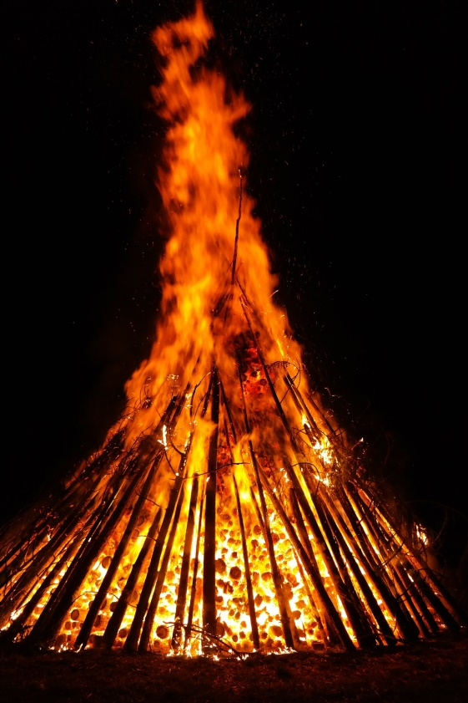
Passion is needed to turn our intentions into activations. However, fire offers us a caution: too much fire in our everyday lives, and we will burn out. We must use fire with respect, turning up the heat to the level needed to effect the change we wish to see, but no more.
The Balefire reminds us of our sacred charge as Medicine Women to:
~ Connect with our ancestors, soul families and communities in circle around the fire
~ Dance and drum and gather our courage and express ourselves in the physical realm
~ Bank embers to sustain our energy
~ Throw the fuel of past choices into the fire to clear them
~ Embrace human sexuality as a form of creative expression

Are you ready to participate with the Medicine Woman through the Element of Fire?

