Medicine Woman Coaching
by Susan Kersey

THE ELEMENT OF WATER
Love • Oneness • Hope
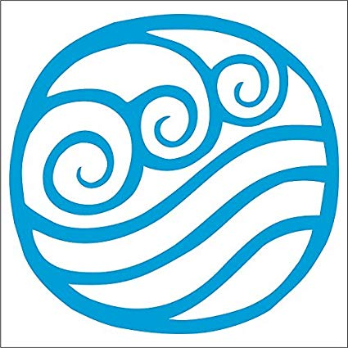

In the Medicine Woman mysteries, we engage with the element of water in order to receive the depth and breadth of emotion.

When we enter the womb…
Water surrounds and protects us in the sacred spaces of the Mother. From water, we understand our personal power in relationship to love, time, and the vastness of soul.

Call in sacred space: Work with a copper or clay bowl of water, fountain, or mirror
When we drink deeply of water, we commit to act from a place of love. Water offers peace, clarity and hope in the face of disaster or despair; it carries our weight and removes gravity from our situations. Water is the pulsing life’s blood of the planet through which we hear the rhythmic heartbeat of the planet and sense our Oneness with all living things.

Receive deep awareness
Find the balance between flow and rhythm, meaning and form

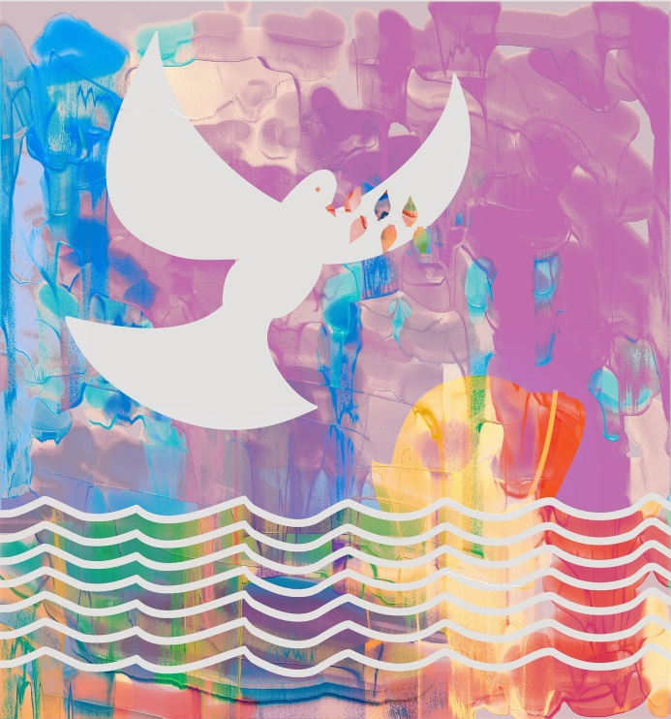
Water requires form in order to take shape. Its currency and power lies in its ability to shift shape and dynamics according to the landscape in which it lies. Water has currency. When it rushes, we feel the positive charge; when deep and dark, we catch our breath and hold it; when stagnant, we sense its dormancy. Water asks us to wash away that which does not serve our highest good. As we take the practical steps required to immerse ourselves in our true heart’s desires, we are able to actively engage with the element of Water.

Are you ready to participate with the Medicine Woman through the Element of Water

